| ***Computer Engineering Department*** |
| --- |
| ***CE100L: Computing Fundamentals & Programming*** |

| ***Course Instructor: Usama Bin Shakeel*** | ***Dated: 01/11/2021*** |
| --- | --- |
| ***Teaching Assistant: Aqsa Khalid*** | ***Semester: Fall 2021*** |
| ***Lab Engineer: Nadir Abbas*** | ***Batch: BSCE2021*** |

# **Lab 6A. Logic Building/Problem Solving**

| **Name** | **Roll number** | **Report**  **(out of 100)** | **Scaled to 10** | **Total**  **(out of 10)** |
| --- | --- | --- | --- | --- |
| Nimra Maqbool | BSCE21012 |  |  |  |

Checked on: ____________________________

Signature: ____________________________

## **Objective**

The goal of this handout is to learn the working of loops in C++.

## **Equipment and Component**

| **Component Description** | **Value** | **Quantity** |
| --- | --- | --- |
| Computer | Available in lab | 1 |

## **Conduct of Lab**

1. Students are required to perform this experiment individually.
2. In case the lab experiment is not understood, the students are advised to seek help from the course instructor, lab engineers, assigned teaching assistants (TA) and lab attendants.

## **Theory and Background**

Programming logic is a set of principles that delineates how elements should be arranged so a computer can perform specific tasks. Logical thinking, whether programming or formal, means applying principles in a disciplined manner to achieve an acceptable result.

**Lab Task**

Take 4 coordinates of the Rectangle and a point P. Your program should be able to tell whether P lies inside the Rectangle or Not.

Sample Input:

P1 0 0

P2 2 0

P3 2 2

P4 0 2

P 1 1

Output: P lies inside Square

### Write pseudocode

| Read x1,y1,x2,y2,x3,y3,x4,y4,x,y  Take values from the user  The we apply condition to check weather it is a rectangle or not  That is : y1==0 && y4==0  OR  x2==0 && x3==0  OR  x1==0 && x4==0  OR  y2==0 && y3==0  If any of this condition is true return true else return false  The we have to apply condition to check weather the point p is in the region of rectangle  We apply the following condition that is :  x>x1 && x<x2  OR  y>y1 && y<y2  If any of this condition is true then return true else false |
| --- |

1. Draw flowchart

|  |
| --- |

1. Write C++ program

| Function .cpp  bool check(int x1, int y1, int x2, int y2,int x3,int y3, int x4, int y4, int x, int y) {  if(y1 == 0 && y4 == 0 || x2 == 0 && x3 == 0) //if these points are zero  return true;  if(x1 == 0 && x4 == 0 || y2 == 0 && y3 == 0) //if these points are zero  return true;  else  false;  }  bool find(int x1, int y1, int x2, int y2,int x3,int y3, int x4, int y4, int x, int y) {  if(x>x1 && x <x2) //if x is greater than x1 and x is less than x2  return true;  if(y>y1 && y <y2) //if y is greater than y1 and y is less than y2  return true;  else  return false;  }  Main.cpp  int main()  {  int x1;  int y1;  int x2;  int y2;  int x3;  int y3;  int x4;  int y4;  int x;  int y;  cout<<"please enter the value of x cordinate of p1"<<endl;  cin>>x1;  cout<<"please enter the value of y cordinate of p1"<<endl;  cin>>y1;  cout<<"please enter the value of x cordinate of p2"<<endl;  cin>>x2;  cout<<"please enter the value of y cordinate of p2"<<endl;  cin>>y2;  cout<<"please enter the value of x cordinate of p3"<<endl;  cin>>x3;  cout<<"please enter the value of y cordinate of p3"<<endl;  cin>>y3;  cout<<"please enter the value of x cordinate of p4"<<endl;  cin>>x4;  cout<<"please enter the value of y cordinate of p4"<<endl;  cin>>y4;  cout<<"please enter the value of x cordinate of p"<<endl;  cin>>x;  cout<<"please enter the value of y cordinate of p"<<endl;  cin>>x;  if(check(x1,y1,x2,y2,x3,y3,x4,y4,x,y) == true)  cout<<"its A Rectangle\n";  else  cout<<"Not\n";  if(find(x1,y1,x2,y2,x3,y3,x4,y4,x,y) == true)  cout<<"Point lies inside the Rectangle\n";  else  cout<<"Noo\n";  }  Output |
| --- |

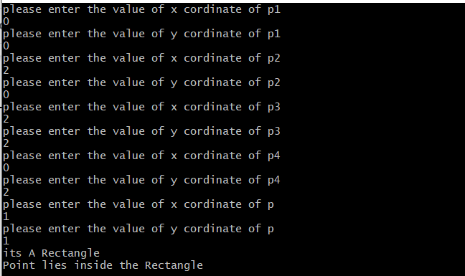

#### **Assessment Rubric for Lab**

**Method for assessment:**

Lab reports and instructor observation during lab sessions. Outcome assessed:

a. Ability to conduct experiments, as well as to analyze and interpret data (P) b. Ability to function on multi-disciplinary teams (A)

c. Ability to use the techniques, skills, and modern engineering tools necessary for engineering practice (P)

| Performance metric | Mapping (task no. and description) | | Max marks | Exceeds expectation | Meets expectation | Does not meet expectation | Obtained marks |
| --- | --- | --- | --- | --- | --- | --- | --- |
| 1. Realization of experiment (a) | 1 | Functionality | 40 | Executes without errors excellent user prompts, good use of symbols, spacing in output. Through testing has been completed (35-40) | Executes without errors, user prompts are understandable, minimum use of symbols or spacing in output. Some testing has been completed (20-34) | Does not execute due to syntax errors, runtime errors, user prompts are misleading or non-existent. No testing has been completed (0-19) |  |
| 2. Teamwork (b) | 1 | Group Performance | 5 | Actively engages and cooperates with other group member(s) in effective manner (4-5) | Cooperates with other group member(s) in a reasonable manner but conduct can be improved (2-3) | Distracts or discourages other group members from conducting the experiment (0-1) |  |
| 3. Conducting experiment (a, c) | 1 | On Spot Changes | 10 | Able to make changes (8-10) | Partially able to make changes (5-7) | Unable to make changes (0-4) |  |
| 2 | Viva | 10 | Answered all questions (8-10) | Few incorrect answers (5-7) | Unable to answer all questions (0-4) |  |
| 4. Laboratory safety and disciplinary rules (a) | 1 | Code commenting | 5 | Observes lab safety rules; handles the equipment and parts with care and adheres to the lab disciplinary guidelines aptly (4-5) | Generally observes safety rules and disciplinary guidelines with minor lapses (2-3) | Disregards lab safety and disciplinary rules (0-1) |  |
| 5. Data collection (c) | 1 | Code Structure | 5 | Excellent use of white space, creatively organized work, excellent use of variables and constants, correct identifiers for constants, No line-wrap (4-5) | Includes name, and assignment, white space makes the program fairly easy to read. Title, organized work, good use of variables (2-3) | Poor use of white space (indentation, blank lines) making code hard to read, disorganized and messy (0-1) |  |
| 6. Data analysis (a, c) | 1 | Algorithm | 20 | Solution is efficient, easy to understand, and maintain (15-20) | A logical solution that is easy to follow but it is not the most efficient (6-14) | A difficult and inefficient solution (0-5) |  |
| 7. Computer use (c) | 1 | Documentation | 5 | Timely documented (4-5) | Late documented (2-3) | Not documented (0-1) |  |
|  | Max Marks (total): | | 100 | Obtained Marks (total): | | |  |

Lab Engineer Signature: ________________________